CHAPTER I

**INTRODUCTION**

**Project Context**

When locating a specific individual's home is critical, a platform that can generate data that connects to where that person is located is critical. The information could include everything from a person's registered house number to their registered barangay. With this, finding a person’s residency can be easily traced and located with the existence of a platform that has the capacity to do the said functionalities. In correlation, the purpose of finding a person’s permanent residency can be for various reasons. It can simply be for leisure or for professional purposes. Regardless, a platform of such capacity can provide a hassle-free manner of locating a person’s permanent residency.

The project aims to have a platform that will address the need to locate the current residence of a person along with their demographic information. In such cases, the intended user will not be fixated on locating a person’s residency because the project will be able to generate the information that corresponds to a person’s location. The information regarding a person will be stored in the system, and the intended user will simply just do a search, and the project will generate the corresponding search result.

  With the current manner of manually locating and tracing the recorded residency of the person, which is time-consuming and requires a lot of effort and means to accomplish the intended output or report, With the help of this project, this issue will be addressed and mitigated. Most barangays have their own personal computers which is commonly located in their respective Barangay Halls. Therefore, information storage and retrieval could have been enhanced.

The Web-Based Barangay Mapping in Consolacion, Sogod, Southern Leyte also records demographic information about the residents. The reports generated by the system include residents per household, sex population structure as grouped by gender.

**Purpose and Description of the Project**

The creation of the project aims to have a more robust means of tracing and finding a person’s residency and generating directions that can be interpreted over a digitized map that can easily be interpreted by the end users. The project will be a web-based application and will be developed using the Laravel 9 PHP Framework and will incorporate Google Maps API, which will be used for tracing, locating, and generating directions regarding a person's current residency. In addition, the project will also generate charts that reflect the general percentage of the population that occupies a barangay based on the census of the barangay.

**Objectives of the Study**

To design, develop and test a web-based residency finder with mapping in Barangay Consolacion, Sogod, Southern Leyte. Specifically, it aims:

1. To create and design a system that will determine the demographic information of a person in Barangay Consolacion, Sogod, So. Leyte.
2. To develop a system that will provide directional guide as to what purok a person is situated in the Barangay Consolacion, Sogod, So. Leyte.
3. To provide a system that will generate census summary via graphs.

**Scope and Limitations of the Project**

The project will be a web-based application and will be tested primarily using the registered residents of Barangay Consolacion, Sogod, and Southern Leyte. Hence, the primary test samples of the project are the registered residents of Barangay Consolacion, Sogod, Southern Leyte. The project will only be accessible using devices that have an internet browser (s) and are connected to the internet. It only tests data that is registered to the system; it won’t be able to interact with data that is not disclosed by any barangay.

CHAPTER II

**REVIEW OF RELATED LITERATURE**

**Related Literature / Theoretical Background**

***Literature Review of GIS, PGIS and ICT***

A review of on-line literature was undertaken among key government agencies and non-government organizations (NGOs) that are, in one way or the other, using Geographic Information Systems or Technologies (GIS/GIT) in the delivery of their mandated services or the further development of such in research and development undertakings. The scanning exercise also tried to capture relevant information and communication technology-based (ICT) initiatives, such as but not limited to the provision of computers and related accessories, broadband, mobile and next generation access (NGA) technologies to the internet, among others.

A quick literature scan was conducted on the use and application of PGIS in the Philippines, as well as within the Asia-Pacific region and elsewhere around the world. The objective of this exercise is to determine the lessons learned from these various local, regional, and international initiatives in the conduct of PGIS and be able to adopt, modify, or enhance and apply (if any) such PGIS methods in the local/Philippine context. (Jose Edgardo Aban (2016). Philippines: Enhancing Community Resource Mapping Through GIS. Technical Assistance Consultant’s Report https://www.adb.org/sites/default/files/project-document/181126/47156-001-tacr-01.pdf)

***Geographical Information Systems (GIS)***

A geographic information system (GIS) is a system that creates, manages, analyzes, and maps all types of data. GIS connects data to a map, integrating location data (where things are) with all types of descriptive information (what things are like there). This provides a foundation for mapping and analysis that is used in science and almost every industry. GIS helps users understand patterns, relationships, and geographic context. The benefits include improved communication and efficiency as well as better management and decision making. (Esri. What is GIS. https://www.esri.com/en-us/what-is-gis/overview)

**Related Studies**

***Orbit rolls out GIS mapping system for housing management***

According to Steve Litchfield (2016), GIS manager at Orbit Group, said: “The business is now utilizing a much more efficient GIS platform, which supports our digital by default agenda and provides staff with the tools they need to deal with customer queries faster and more effectively, in turn improving our overall customer satisfaction levels. I was the go-to person when staff required specific geographic information, maps and analysis, but this was unsustainable as the business grew. Together with Cadcorp we have evolved the system to ensure it meets the needs of the business and enables staff to self-serve. The feedback and usage from staff has been excellent. (Richard Spooner, Manager, Cadcorp, +441438747996 Email: richard.spooner@cadcor.com http://[www.directionsmag.com](http://www.directionsmag.com/)/pressrelease/6033)

***Barangay Decision Support and Mapping System***

The system is designed to allow the storage and retrieval of the record of all the residents in the barangay; allow the user to create and edit the barangay map using the generally-accepted symbols or icons which represents the natural and man-made features within the barangay; automate the processing of barangay clearances, permits and similar documents issued by the barangay; allow the storage and retrieval of barangay-approved ordinances, resolutions and other necessary reports; record environmental problems in the barangay and the solutions provided; record and retrieve cases of domestic violence, child abuse and barangay hazards and the actions taken by the concerned officials; and provide the necessary reports including existing businesses, demography, residents by household, population structure, children’s nourishment, literacy distribution, domestic violence, household composition, households by dwelling, employment distribution, barangay hazards, barangay residents, minutes of meetings, barangay ordinances, barangay resolutions, and barangay topography. (Tracy N. Tacuban (MSCS), (2016). Barangay Decision Support and Mapping System. http://www.apjmr.com/wp-content/uploads/2016/04/APJMR-2016.4.2.02.pdf)

CHAPTER III

**TECHNICAL BACKGROUND**

**Technicality of the Project**

The project will be implemented as a Web-based application; hence it will only be accessed if internet connection existent and accessible. This goal can be achieved with help of the data that are disclosed by authorized person of the barangay that will be tested and validated so the system can generate digitized map with directions, and charts that will reflect that summary census of the barangay. The proponents will develop the project using Laravel 8, which is a PHP Framework for web-development.

**Details of the Technologies to be Used**

The project will be a web-based application and order for this project to be implemented as intended the following packages, libraries, Framework and API will be used:

* Laravel 9 – a PHP framework for web development.
* PHP – a Programming language that will serve as project main programming language.
* Bootstrap – a web-development designing framework
* AJAX – a synchronized JavaScript and XML
* jQuery – a JavaScript library or Framework
* CSS – a web-development designing platform
* Google Charts API – an API for generating Charts.
* Leaflet Maps API – an API for creating digitized map.
* MySQL Database – use for storing data and/or information.

The project will programmatically be structured with RESTful API and for this project to be achieved the essential packages / libraries should be curated with the project to support its suitable needs and requirements.

**How the Project will Work.**

Figure 1 shows the Conceptual Framework of the project. The diagram illustrates that the project will handle two sides, one for Authorized Personnel and another for the Public User. Each side of the project will be able to handle functions and is capacitated to validate and generate reports/outputs that corresponds to the functionality. The Authorized Personnel comprises of those that are authorized to disclose information that corresponds the residency of each populace of the barangay that they belong to. On the other hand, the Public User(s) are those that simply wants to find out where a person is currently situated and in need of directions to locate that person.

Figure 1. Conceptual Framework

Figure 2. shows the project Conceptual Framework of the Authorized Personnel. The figure illustrates the functionalities that the authorized personnel can perform and is enabled by the system. The authorized personnel will be able to Login/Sign up to the system, which will be validated and be stored/saved to the database. Upon login into the system, the authorized personnel can register the record of residency or list of populaces of the barangay to system, which will also be stored to the database. With the stored list of residencies of the barangay, the authorized personnel can now view the generated chart by the 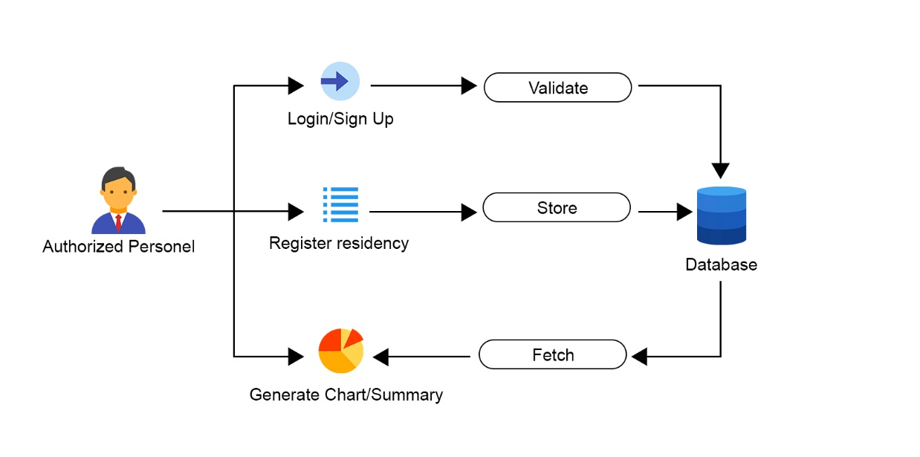system, which reflects the summary of the specified barangay.

Figure 2. Conceptual Framework for Authorized Personnel

Figure 3 shows the Conceptual Framework of User. The figure illustrates the capabilities that user side can is capacitated to perform. Upon accessing the system online, the user can do a Person search, which the system will fetch from database. The system will generate the corresponding information(s) regarding the provided information by the user. The person can view a digitized map based on generated report of the system, which will enable the user to view information relating to where the person is located.

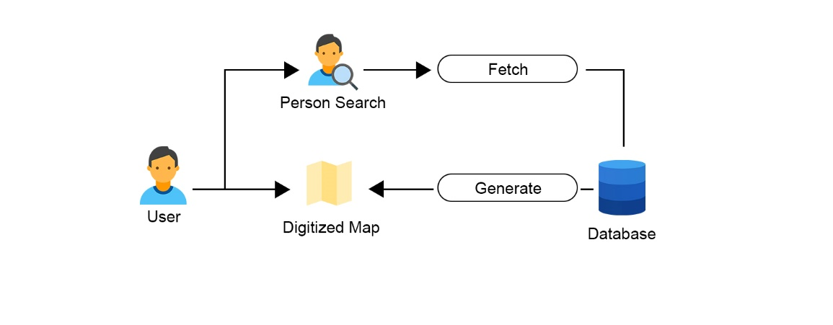

Figure 3. Conceptual Framework for User

CHAPTER IV

**Methodology**

**Environment**

***Locale***

The project was conducted at barangay Consolacion, Sogod, Southern Leyte. The residents of barangay Consolacion, Sogod, Southern Leyte served as the primary test samples for the project. Barangay Consolacion situated within Sogod and the town of Sogod is located along the Southern Leyte section of the Pan-Philippine Highway, 126 kilometers (78 miles) south of Tacloban City, the regional center of Eastern Visayas.

***Population******of the Study***

The population of the study are primarily, the residents of barangay Consolacion, Sogod Southern Leyte. Which served as the primary test samples for the project to generate appropriate charts and reports. In addition are the authorized person that are permitted to disclose information relating to residency and the public users of the system.

***Organizational Chart/Profile***

The project does not serve any organization, establishment, or company. Hence, the project will not represent any organizational process, flow, and conduct of transaction.

**Requirement Specification**

***Operational Feasibility***

*Fishbone Diagram*

The diagram below reflects the fishbone diagram of the study. It shows what are the factors contributing to the main problem, in which the study intends to address. The factors are each mentioned in each branch of the fishbone diagram and in addition are the specified facts which led to problems and scenario that are listed in the diagram.

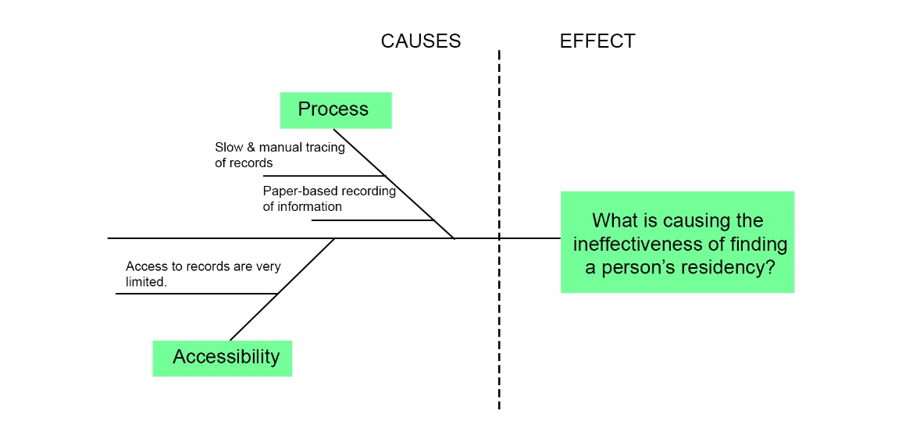

Figure 4. Fishbone Diagram.

*Functional Decomposition* *Diagram*

The diagram below shows the functional decomposition diagram of the system. It depicts the process of each of the system side, the authorized personnel side and the user side. It shows the different processes that each side can validate.

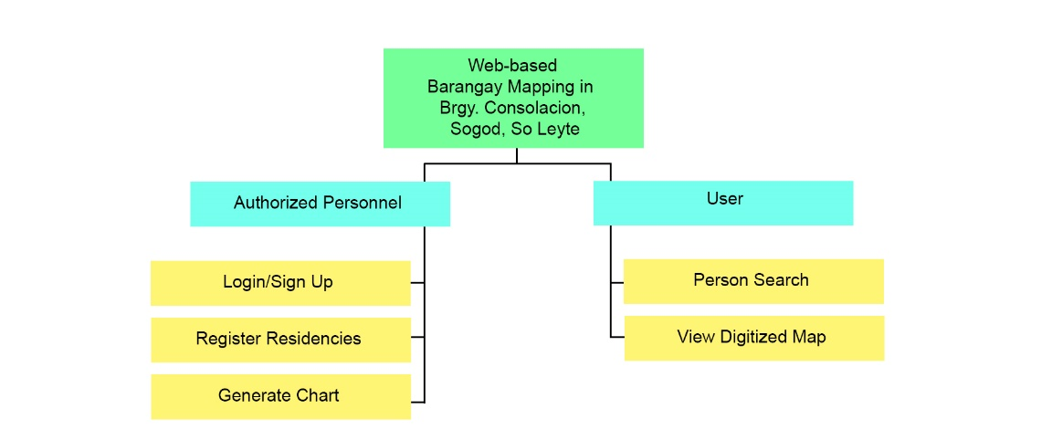

Figure 5. Functional Decomposition Diagram.

***Technical Feasibility***

*Compatibility Checking (Hardware/Software)*

The project can function, manipulate, and validate data with internet browsers that can compile front-end libraries and packages. The project can be accessed by users with internet browsers such as Google Chrome, Microsoft Edge, Opera Mini, Mozilla Firefox. The system can also function on devices that is based operating systems such as, Windows and Android.

*Relevance of the Technologies*

The technologies that the proponents utilized in the creation of the project contributed to making the project fully functional. The technologies enabled the project to be capacitated in accepting and validating inputs and generating accurate reports. The technologies also paved the means in testing the project and making the project fault free as possible.

***Schedule Feasibility***

*Gantt Chart*

The following chart show the list dates and the duration that took place as the proponents works on the project. The project implementation phase is listed along with its corresponding date and time duration.

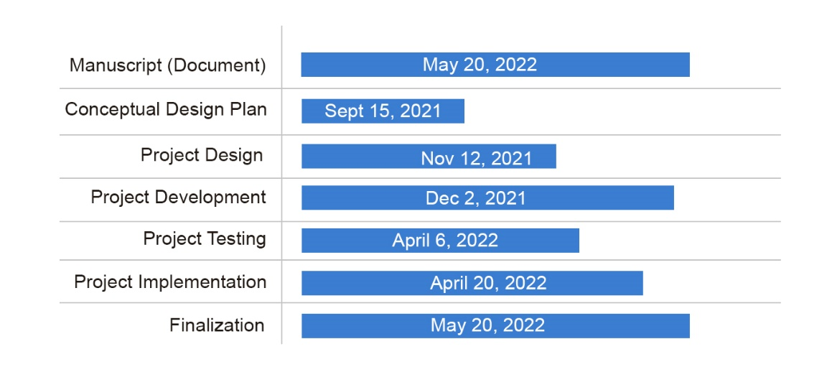

Figure 6. Gantt Chart

***Economic Feasibility***

*Cost and Benefit Analysis*

The table below reflects the Cost and Benefit Analysis of the project. The table lists out the essential matters that the proponents need to complete the study in its entirety. The table shows the internet expenses has accumulated most of the expenses because the proponents needed internet access in accomplishing the project.

|  |  |
| --- | --- |
| Expenses | Amount |
| Internet Expenses | 1,000.00 |
| Paper & Photocopy Expenses | 500.00 |
| Transportation | 1,000.00 |
| Miscellaneous | 500.00 |
| Total | 3, 500.00 |

Table 1. Cost and Benefit Analysis

*Cost and Recovery Scheme*

The following table is the Cost and Recovery Scheme of the study. It depicts the division of the expenses during the duration of accomplishing the project. The table also shows that the expenses increase in each month because the project required excessive expenses as it reaches its completion.

|  |  |  |  |  |  |
| --- | --- | --- | --- | --- | --- |
| Expenses | Jan | Feb | Mar | Apr | May |
| Internet Expenses | 200.00 | 200.00 | 200.00 | 200.00 | 200.00 |
| Paper & Photocopy Expenses | 0 | 0 | 0 | 0 | 500.00 |
| Transportation | 200.00 | 0 | 0 | 200.00 | 600.00 |
| Miscellaneous | 100.00 | 100.00 | 100.00 | 100.00 | 100.00 |
| Total | 500.00 | 300.00 | 300.00 | 500.00 | 1,400.00 |

Table 2. Cost and Recovery Scheme

***Requirements Modelling***

*Inputs*

The following are the inputs for the Authorized Personnel side of the system.

* The authorized personnel must first register for an account with his/her information that are required by the website, this includes his/her Full name, e-mail, password, and home address.
* The authorized personnel must register a resident of his/her barangay individually with information such as, first name, middle name, last name, suffix if any and so on.
* The authorized personnel can also, update, delete information of registered residency of his/her barangay.

The following are the inputs for the users’ side of the system.

* Upon accessing the system, the user can do a person search. By choosing from the search type that is offered by the system, the user can search by first name, middle name, and last name.
* The user can find location a person from the person search results.

*Processes*

The following are the process for the authorized personnel side of the system.

* Upon logging in the system must validate the login credentials of the authorized person.
* Upon registering for an account, the system must validate input.
* The system must be able to determine the authorized personnel home address or barangay.
* Upon entering information regarding a person’s residency details, the system must validate the input and check if they have no errors.
* The system must generate a table from registered residency by the authorized person.
* The system must be able to interpret, and group registered residency to generate graphical presentation of data.

The following are the processes for the user side of the system.

* The system must validate the search input for accurate fetching of data.
* The system must be able to classify stored information based on the users’ chosen search type.
* The system must be able to classify search result addresses to generate directions using map.

*Output*

The following are the outputs for the authorized personnel side of the system.

* The system must group data and generate table based on the grouped data.
* The system must generate graphical presentation of data using pie charts.

The following are the outputs for users’ side of the system.

* The system must be able to display and use maps based on search result.
* The system must be able to generate reports based on generated search result.

*Performance*

The following are the performance condition of the system. These applies to both sides, the authorized personnel side and users’ side of the system.

* The system must be accessible for multiple logins and register request.
* The system must be able to handle multiple person search in the public users’ side of the project.
* The system must access map and generate accurate results and reports.

*Controls*

The following are the controls that applies to both authorized personnel and user’s side of the project.

* The authorized personnel can only do its designated task on the website if he/she has logged in to the website.
* The system can only validate and generate reports if the entered data associated with a person’s residency are accurate.
* The user can only search a person’s residency if there are stored data within the system’s database.

*Data and Process Modelling*

The diagram below is the context diagram of the study it shows the overall context on which the system operates and validates. The diagram comprises of the essential reports, capabilities and/or functions for both the public users and the authorized personnel.

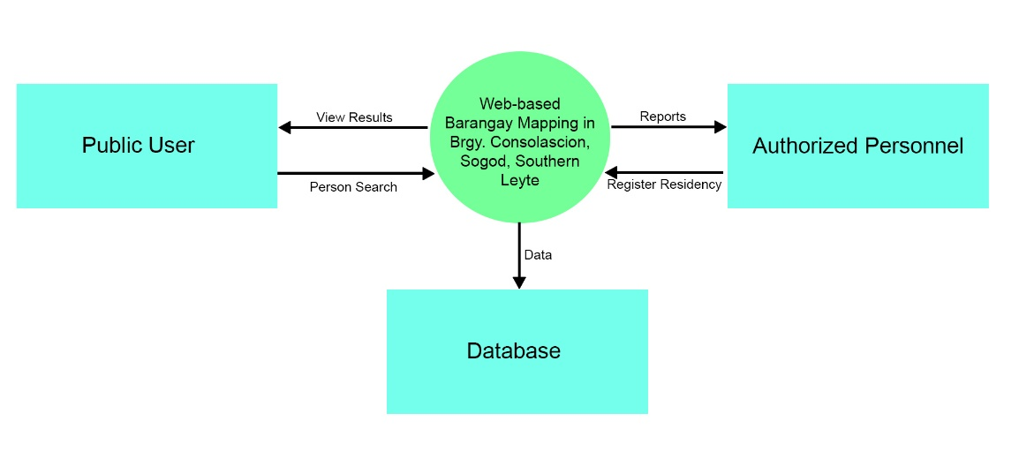Figure 7. Context Diagram.

The following figures are the data flow diagrams for each side of the project. Each diagrams depicts how data flows for the public users’ side and for authorized side of the project. In addition, the diagrams also show the general reports that each side of the project generates and displays.

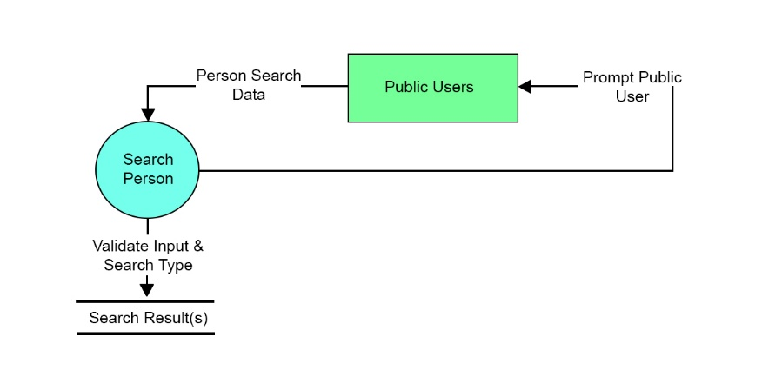

Figure 8. Data Flow Diagram for the Public Users side.

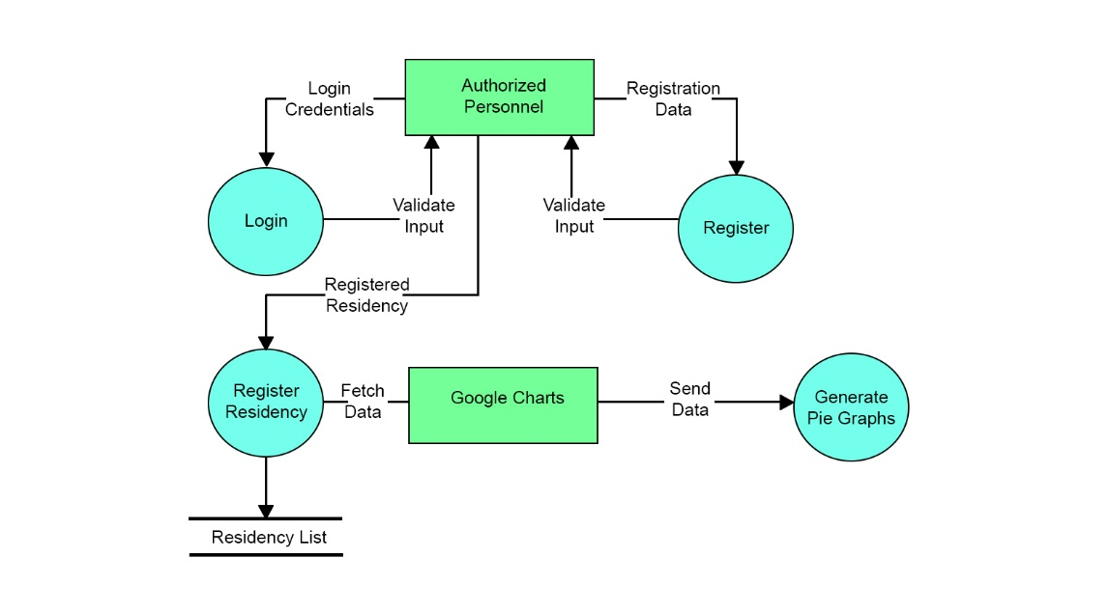Figure 9. Data Flow diagram for the Authorized Personnel Side.

The figure below shows the overall system flow of the project. It depicts how the system handles inputs and displays reports and, what are the conditions that the system considers in each task and/or functionalities. This applies for the Public Users side and Authorized Side of the project.

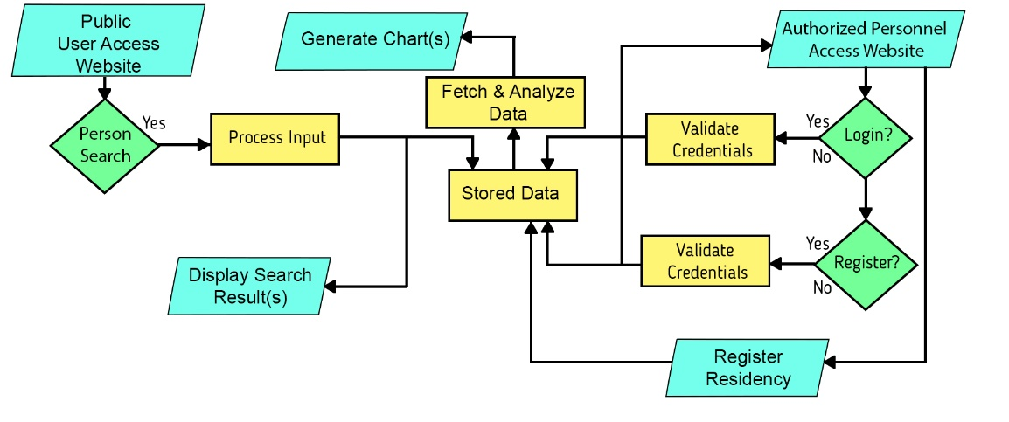

Figure 10. System Flow Chart.

The figure below is the Program Flow chart for the Public Users side of the project. The diagram highlights how this side of the project deals inputs and displays reports in a programmatical sense.

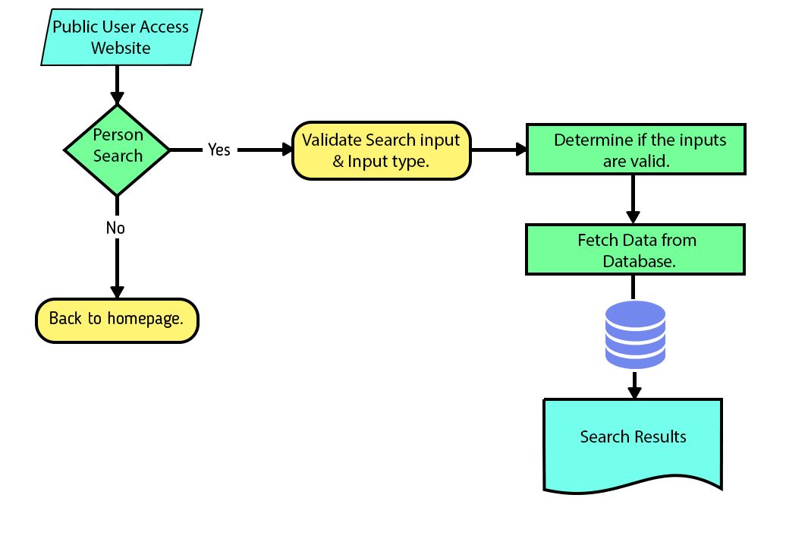

Figure 11. Program Flow Chart for the Public Users Side.

The following diagram shows the Program Flow Chart for Authorized Personnel Side of the project. It also highlights how this side of the project deals inputs and displays reports in a programmatical sense.

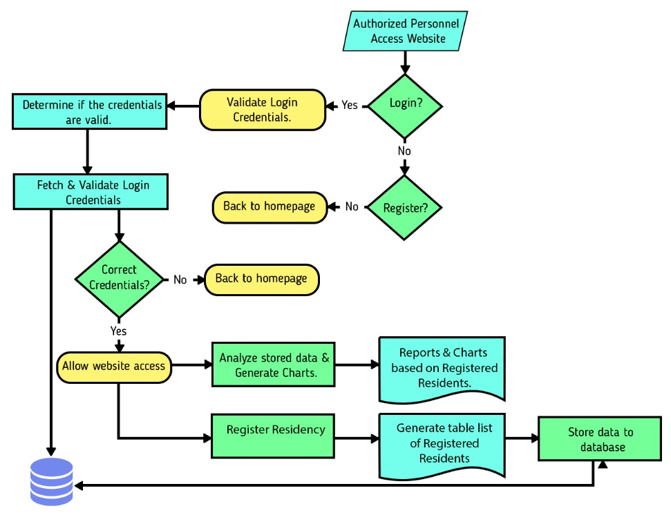

Figure 12. Program Flow Chart for the Authorized Personnel Side.

***Risk Assessment/Analysis***

The following table is the risk assessment/analysis conducted by the proponents of the study. The table reflects the risks and possible hindrances that the system will encounter along with its corresponding mitigation method for preventive measures.

|  |  |  |  |
| --- | --- | --- | --- |
| Threat | Impact | Risk | Mitigation |
| System Failure | Service will be unavailable | Data will not be stored. | Implement Browser Caching. |
| Malicious Human Interference  (DDOS Attack) | Source Code and data will be breached. | Services and Data breached. | Implement Laravel cross site forgery system. |
| Accidental Human Interference and Data Deletion | Permissions and prompts are configured properly. | Source Code, Services and Data breached. | Implement Laravel cross site forgery system. |

Table 3. Risk Assessment/Analysis

**Design**

***Output and User-Interface Design***

*Forms*

The following are the forms that are accessible within the website/system which can be found either in the Authorized Personnel side and Public User side of the system. The forms also highlight what are the required input for the system to function accurately and accordingly.

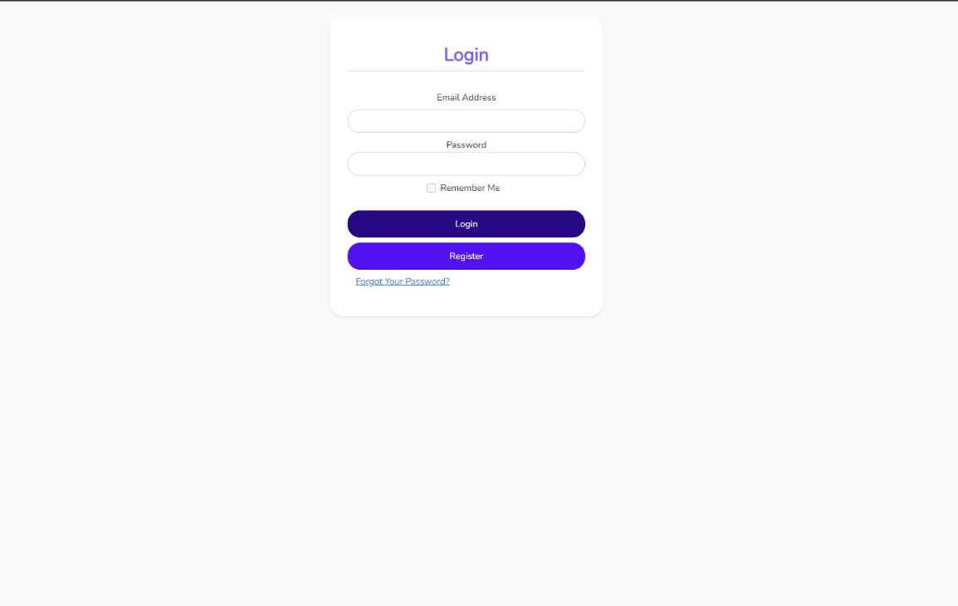

Form 1. Authorized Personnel Login Form

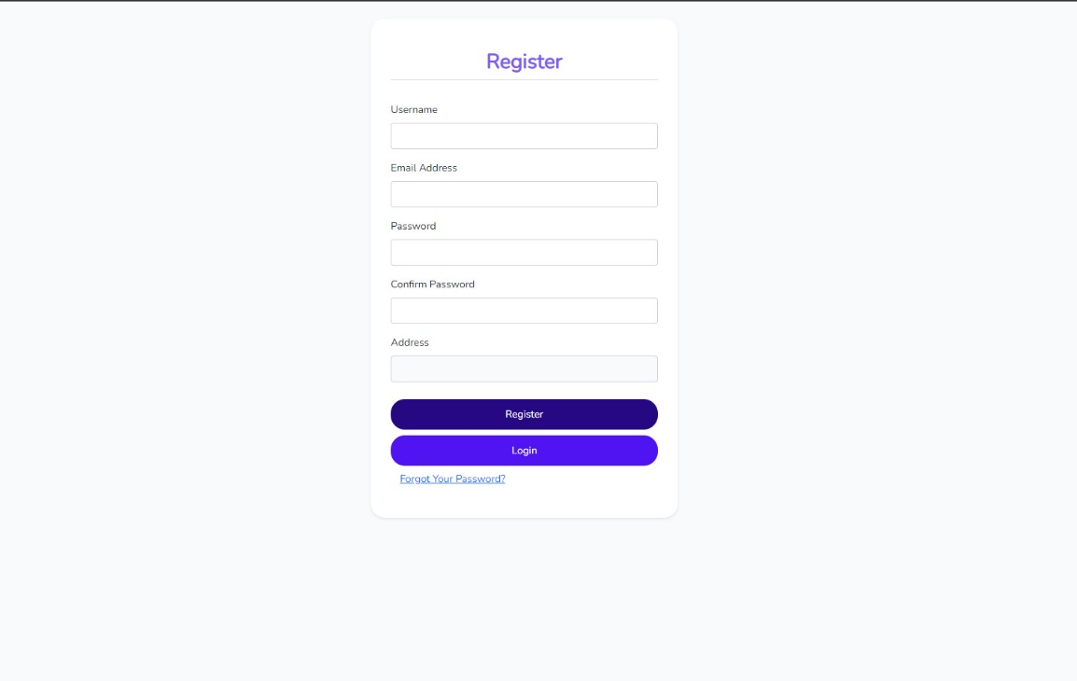

Form 2. Authorized Personnel Registration Form

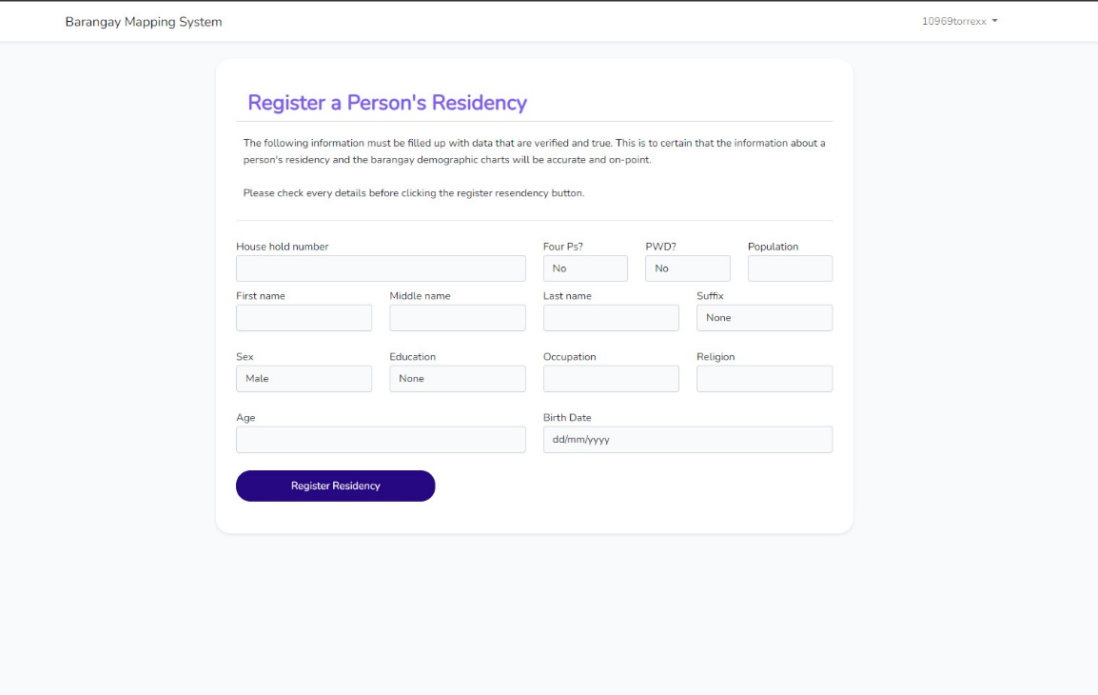

Form 3. Authorized Personnel Register Residency Form

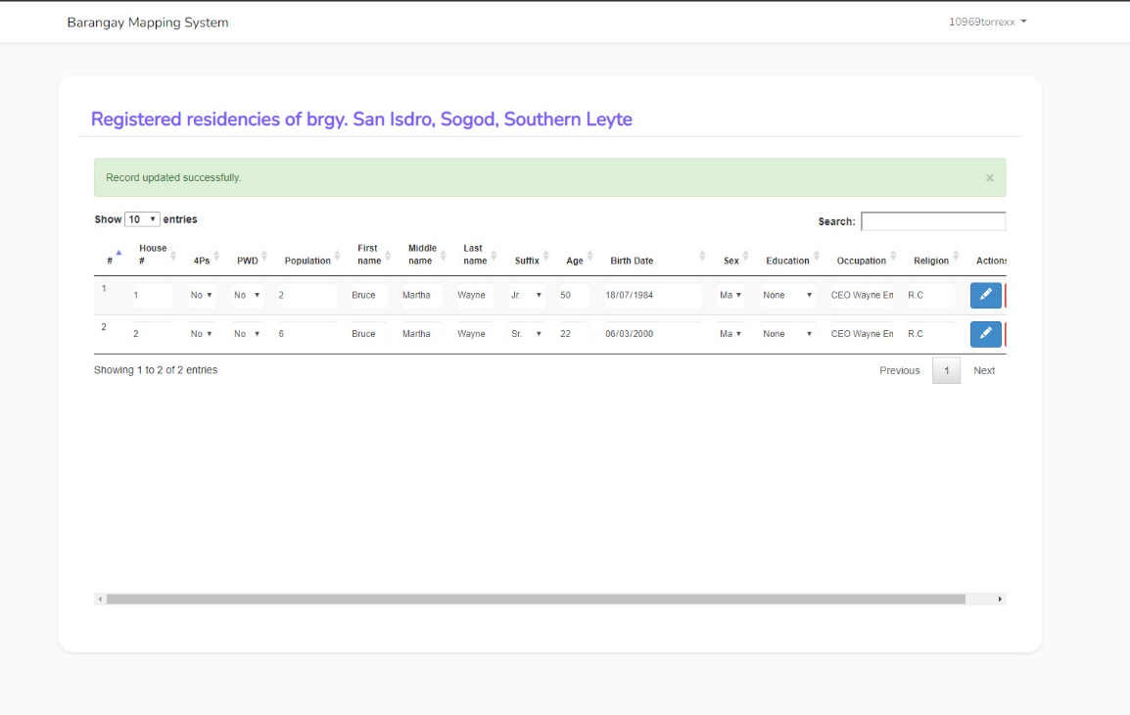

Form 4. Authorized Personnel List of Registered Residency

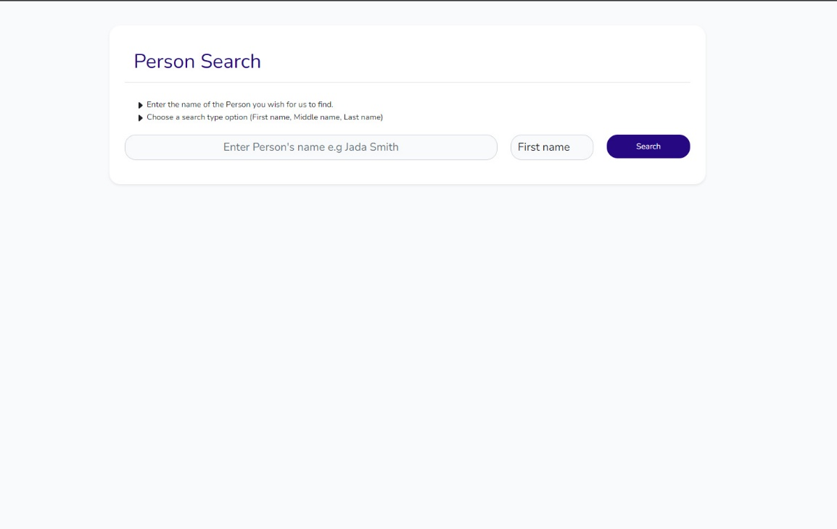

Form 5. Public User Search Person Form

*Reports*

The following are the reports that system generates based on the required inputs from the Public Users side and from the Authorized Personnel of the project. The reports are the result of the system’s capability to analyze, process and validate data gathered from both sides of the system.

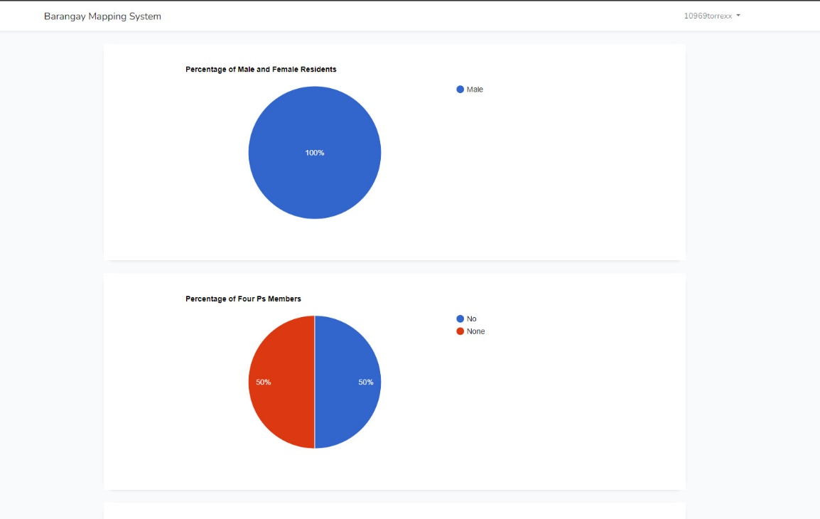

Report 1. Generated Pie Graph Based on Recorded Data

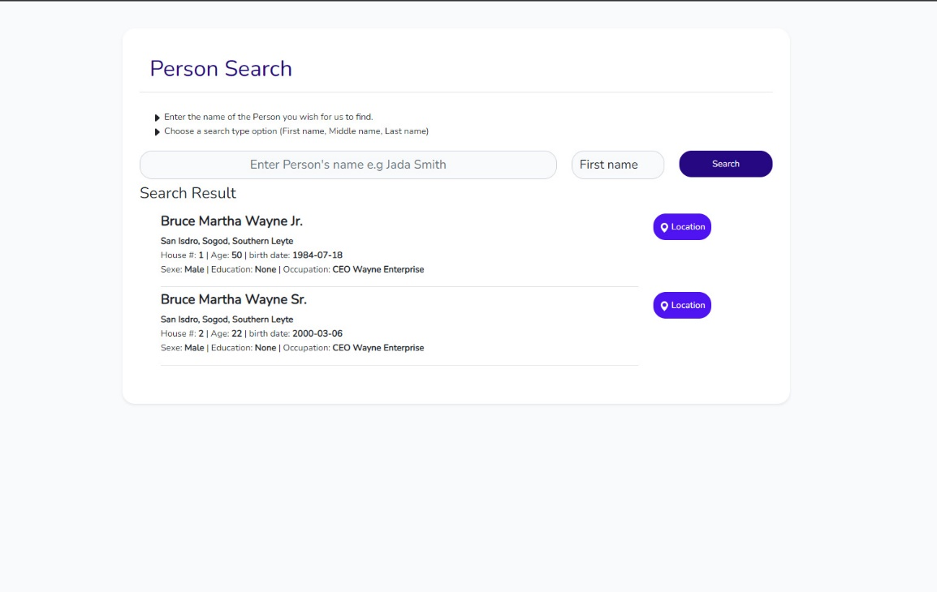

Report 2. Generated Search Result Based on Recorded Data

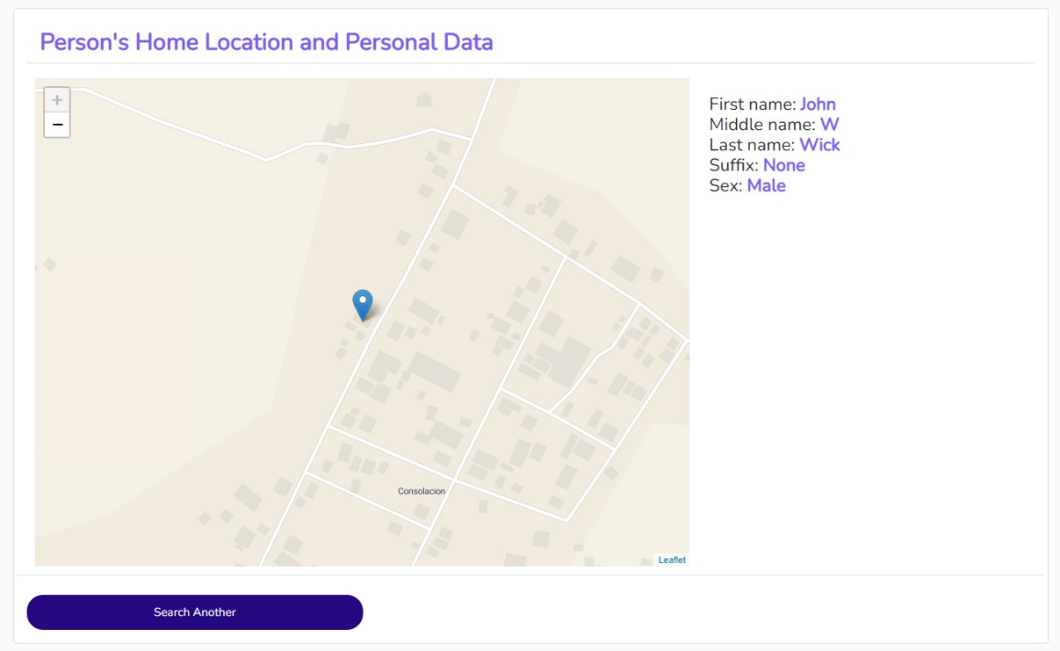

Report 3. Generated Map along with Corresponding Address

***Data Design***

*Entity Relationship Model*

The diagram below is the system’s entity relationship diagram. It shows that there are only two tables associated within the system, but it has paved means to make the system efficient and have a fast-response time.

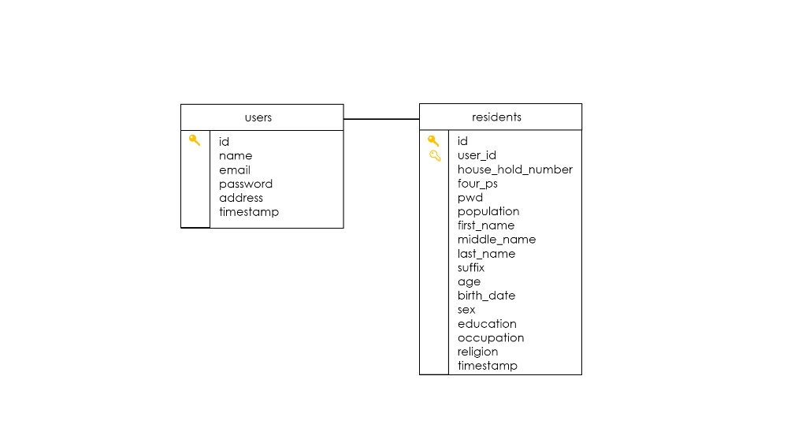

Figure 13. Entity Relationship Model

*Data Dictionary*

The following table shows the system’s data dictionary. It reflects the kind of data that the system handles, validates, stores and prints. The dictionary is based on the Entity relationship model that is included prior to this section.

|  |  |  |  |  |
| --- | --- | --- | --- | --- |
| Field name | Data type | Field size | Description | Example |
| Id | Big int | 10 | Unique primary key for each user | 1 |
| Name | String | 255 | Name for each of the user | John Doe |
| Email | String | 255 | E-mail for each of the user | [johndoe@gmail.com](mailto:johndoe@gmail.com) |
| Password | String | 255 | Hashed password of each of the user | $alijbakjwbdajwbakj.. |
| Address | String | 255 | Address of each of the users |  |

Table 4. Data Dictionary for Users table

|  |  |  |  |  |
| --- | --- | --- | --- | --- |
| Field name | Data type | Field size | Description | Example |
| Id | Big int | 10 | Unique primary key for each user | 1 |
| User id | Int | 10 | Foreign key for each resident | 1 |
| Household number | string | 255 | Household number for each resident | 12 |
| Four Ps | String | 255 | Four Ps membership classification of each resident | Yes |
| PWD | String | 255 | PWD membership classification of each resident | No |
| Population | String | 255 | Population of each resident | 5 |
| First name | String | 255 | First name for each of the resident | John |
| Middle name | String | 255 | Middle name of each of resident | Morgan |
| Last name | String | 255 | Last name of each the resident | Marston |
| Suffix | String | 255 | Associated suffix of each resident | Jr. |
| Age | Int | 10 | Age of each user | 22 |
| Birth Date | Date |  | Associated birth date of each resident | 03-06-00 |
| Sex | String | 255 | Sex of each resident | Male |
| Education | String | 255 | Educational attainment of each user | Highschool Graduate |
| Religion | String | 255 | Religion of each resident | Roman Catholic |
| Timestamp | Date |  | Generated timestamp of each user | 04-09-22 |

Table 5. Data Dictionary for the Residents Table

***System Architecture***

*Network Model*

The following figure is Network Model of the system. It shows how each object, modules, classes, and controls from the Public Users and from Authorized Personnel interacts and relates to each other task and functionalities.

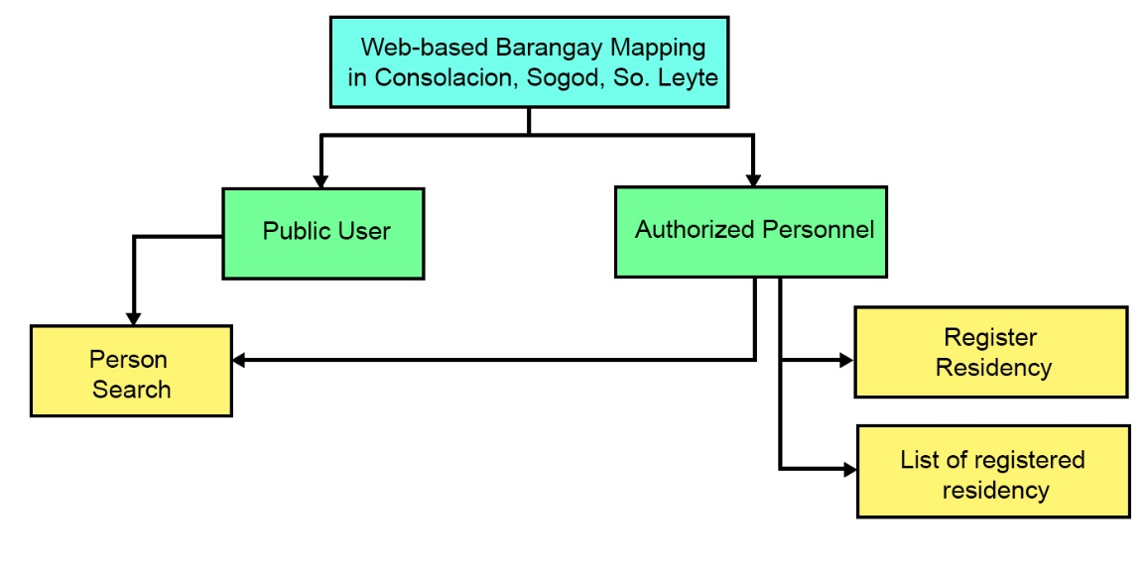

Figure 14. Network Model

*Network Topology*

The diagram below illustrates how the interactions between modules from the Public Users side and from Authorized Personnel interacts over the internet. It also shows how the system handles requests and actions made from each side of the system.

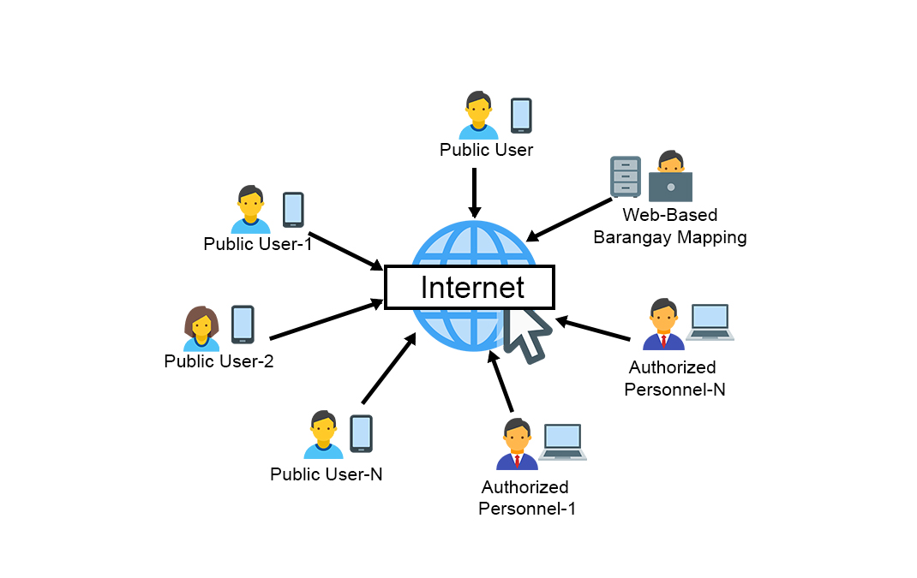

Figure 15. Network Topology

*Security*

The diagram below shows how the system’s implementation of its security measures. It illustrates how the system will handle any possible security breach and where and how can the system be maintained during its implementation.

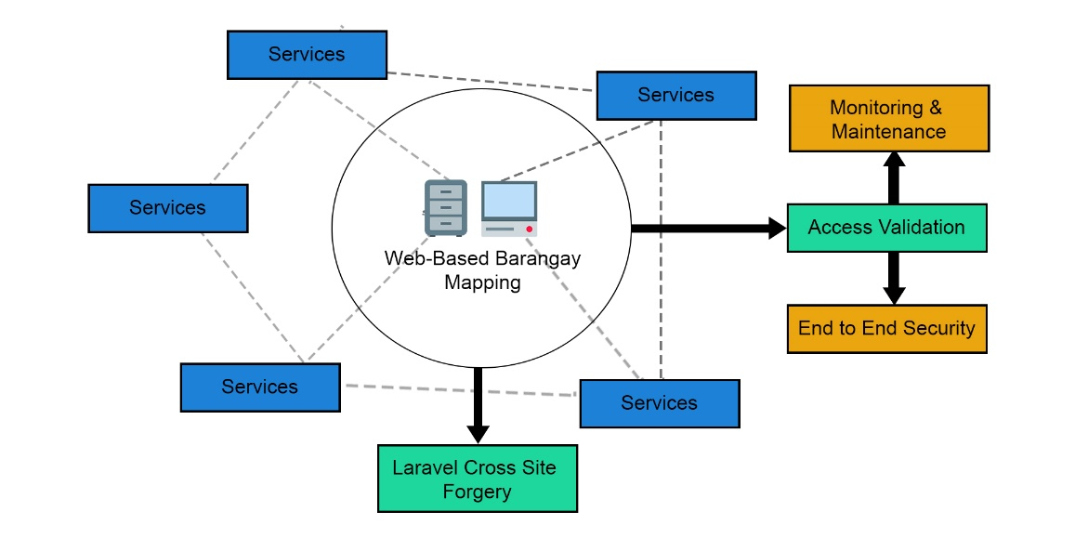

Figure 16. Security

**Development**

***Software Specification***

The following are the required software specification for the system to be accessible and be fully functional for both the Authorized Personnel and the Public Users.

* Operating system
  + Windows 7-11
  + Latest android versions
  + Mac OS
  + Linux
  + iOS
* Brower
  + Google Chrome
  + Microsoft Edge
  + Opera Mini
  + Mozilla Firefox
* Brower Extension and tools
  + Adobe Flash Player

***Hardware Specification***

The following are the required hardware specification for the system to be accessible and be fully functional for both the Authorized Personnel and the Public Users.

* 2GB Ram and Above
* At least Inter Core i3

***Program Specification***

The following are the required program specification for the system to be accessible and be fully functional for both the Authorized Personnel and the Public Users.

* Programming Language Support
  + PHP
  + JavaScript

***Programming Environment***

|  |  |
| --- | --- |
| Front End | Back End |
| * Hyper Text Markup Language * Cascading Style Sheet * Bootstrap * jQuery * JavaScript | * **PHP language** * **Laravel Migrations** * **MySQL** * **AJAX** * **Google Charts** * **Leaflet** |

Table 6. Project Programming Environment

***Deployment Diagram***

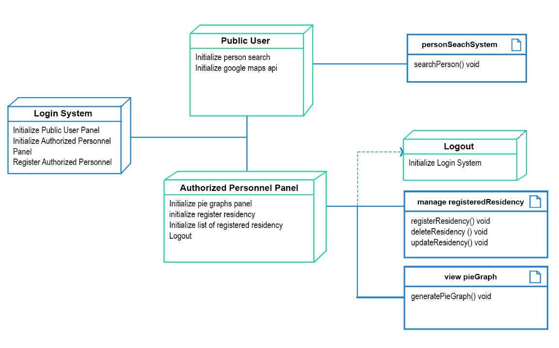

Figure 17. Deployment Diagram

***Test Plan***

|  |  |  |  |
| --- | --- | --- | --- |
| Test Case | Description | Test Step | Expected result |
| Functionality | Each functionality, features, capability of the system. | Inputs, reports and request can be done simultaneously for both sides | Reports should be accurate. Function w/o errors. |
| Response Time | The amount of time for the system to generate reports and validate inputs. | Output and report generation is fast for both sides. | Response is fast and input validation is efficient. |
| Security | Ensure login credential checking. | Should be able to login according to login credentials. | Entered data are secured. |
| Usability | Each side is accessible. | Public users can search and trace location. Authorized personnel can do task seamlessly. | Every function can be done with no errors. |

Table 7. Test Plan

**Testing**

***Unit Testing***

The following tables are the unit testing for each module that the project use. Every module represents a single form in the project, and each module is tested according to its nature and purpose and for its expected result.

|  |  |  |  |
| --- | --- | --- | --- |
| Login Form | | | |
| Field | **Event** | Failed | Success |
| Email Address | Text changed | Error message – “Please fill form accordingly”. | Initialize login and validate input. |
| Password | Text changed | Error message – “Please fill form accordingly”. | Initialize login and validate input. |
| Remember me | Click event | No implemented action. | No implemented action. |
| Login button | Click event | Error message – “Please fill form accordingly”. | Initialize login and validate input. |
| Register button | Click event | No implemented action | Initialize register page. |

Table 8. Unit Testing Result 1.

|  |  |  |  |
| --- | --- | --- | --- |
| Register Form | | | |
| Field | **Event** | Failed | Success |
| Username | Text changed | Error message – “Please fill form accordingly”. | Initialize register and validate input. |
| Email address | Text changed | Error message – “Please fill form accordingly”. | Initialize register and validate input. |
| Password | Text changed | Error message – “Please fill form accordingly”. | Initialize register and validate input. |
| Confirm Password | Text change | Error message – “Password input doesn’t match”. | Initialize register and validate input. |
| Address | Text Change | Error message – “Please fill form accordingly”. | Initialize register and validate input. |
| Register button | Click event | No implemented action | Initialize register and validate input. |
| Login Button | Click event | No implemented action | Initialize login page. |

Table 9. Unit Testing Result 2.

|  |  |  |  |
| --- | --- | --- | --- |
| Register a Person’s Residency Form | | | |
| Field | **Event** | Failed | Success |
| Household number | Text changed | Error message – “Please fill form accordingly”. | Initialize register and validate input. |
| Four Ps | Text changed | Error message – “Please fill form accordingly”. | Initialize register and validate input. |
| PWD | Text changed | Error message – “Please fill form accordingly”. | Initialize register and validate input. |
| Population | Text change | Error message – “Please fill form accordingly”. | Initialize register and validate input. |
| First name | Text Change | Error message – “Please fill form accordingly”. | Initialize register and validate input. |
| Middle name | Text change | Error message – “Please fill form accordingly”. | Initialize register and validate input. |
| Last name | Text change | Error message – “Please fill form accordingly”. | Initialize register and validate input. |
| Suffix | Text change | Error message – “Please fill form accordingly”. | Initialize register and validate input. |
| Sex | Text change | Error message – “Please fill form accordingly”. | Initialize register and validate input. |
| Education | Text change | Error message – “Please fill form accordingly”. | Initialize register and validate input. |
| Occupation | Text change | Error message – “Please fill form accordingly”. | Initialize register and validate input. |
| Religion | Text change | Error message – “Please fill form accordingly”. | Initialize register and validate input. |
| Age | Text change | Error message – “Please fill form accordingly”. | Initialize register and validate input. |
| Birthdate | Date select | Error message – “Please fill form accordingly”. | Initialize register and validate input. |
| Register Residency | Click event | No implemented action | Initialize register and validate input. |

Table 10. Unit Testing 3.

|  |  |  |  |
| --- | --- | --- | --- |
| View list of registered residency table | | | |
| Field | **Event** | Failed | Success |
| Household number | Text changed | Error message – “Please fill form accordingly”. | Initialize update and validate input. |
| Four Ps | Text changed | Error message – “Please fill form accordingly”. | Initialize update and validate input. |
| PWD | Text changed | Error message – “Please fill form accordingly”. | Initialize update and validate input. |
| Population | Text change | Error message – “Please fill form accordingly”. | Initialize register and validate input. |
| First name | Text Change | Error message – “Please fill form accordingly”. | Initialize update and validate input. |
| Middle name | Text change | Error message – “Please fill form accordingly”. | Initialize update and validate input. |
| Last name | Text change | Error message – “Please fill form accordingly”. | Initialize update and validate input. |
| Suffix | Text change | Error message – “Please fill form accordingly”. | Initialize update and validate input. |
| Sex | Text change | Error message – “Please fill form accordingly”. | Initialize update and validate input. |
| Education | Text change | Error message – “Please fill form accordingly”. | Initialize update and validate input. |
| Occupation | Text change | Error message – “Please fill form accordingly”. | Initialize update and validate input. |
| Religion | Text change | Error message – “Please fill form accordingly”. | Initialize update and validate input. |
| Age | Text change | Error message – “Please fill form accordingly”. | Initialize update and validate input. |
| Birthdate | Date selects | Error message – “Please fill form accordingly”. | Initialize update and validate input. |
| Update | Click event | No implemented action | Initialize update and validate input. |
| Delete | Click event | No implemented action | Initialize delete and validate input. |

Table 11. Unit Testing 4.

|  |  |  |  |
| --- | --- | --- | --- |
| Person Search Form | | | |
| Field | **Event** | Failed | Success |
| Search text field | Text changed | Error message – “Please fill form accordingly”. | Initialize search and validate input. |
| Search type | Text change | Error message – “Please fill form accordingly”. | Initialize search and validate input. |
| Search button | Click event | Error message – “Please fill form accordingly”. | Initialize search and validate input. |

Table 12. Unit Testing 5.

***Integration Testing***

*Compatibility Testing*

The project, by its nature, was tested on the following internet browsers to determine if the project’s functionalities, modules, and purpose are on its intended outcome.

1. Google Chrome
2. Microsoft Edge
3. Mozilla Firefox
4. Opera Mini

*Performance Testing*

Testing the performance of the system was next in the project testing phase. The project by its web-based nature shows that the performance of the system solely contributed by the system connectivity over the internet. In addition, the APIs that the system is integrated upon highly depends on the internet connectivity. Regardless to any browser that the system is accessed to, the internet connectivity must still be observed. Excluding this circumstance, the project proved to effective and functional.

*Stress Testing*

In testing the system’s capacity to function even beyond its expected usage. Hence, the system’s capacity to handle stress through numerous data request and validation was put to test by simultaneously accessing the system with the upper mentioned internet browsers.

*Load Testing*

The system’s capacity to handle numerous data was tested by storing loads of residency and registering accounts from the authorized personnel side of the project. It was determined that data retrieval from the public users’ side the project takes more time if stored data unto its database reach a certain amount.

***System Testing***

The system has undergone standard testing phases that was stated in this study. The testing phase that the system has undergone is a total of six testing phases and each of the testing phases, tested the system’s capacity to function and operate if certain operational obstacle were met. Regardless, the system has been successful in all its key aspects that was tested during its development.

**Conclusions**

Based on the findings and the data gathered, the proponent of the study concludes that:

1. The system is effective in retrieving intended information regarding a person’s residency.
2. The system is, nonetheless, effective in retrieving and locating a person’s location based on stored location data.

**Recommendations**

The system is useful and provides advantages in locating the residency of a person. However, the system in its entirety, is limited. Therefore, the proponents recognize and recommends that an owned or localized map service provider will be integrated in the system to allow more features to be added to the system.

**Implementation Plan**

***Project Implementation Plan***

In the project implementation phase, the proponents considered facts that would pave more means to make the implementation as effective and accurate as possible. The following table comprises is the lists of matters to tend to implement the project and make it efficient as possible.

|  |  |  |
| --- | --- | --- |
| # | Task | Status |
| 1. | Project Implementation Meeting |  |
| 2. | System presentation Planning |  |
| 3. | Deployment Procedure |  |
| 4. | System Testing |  |
| 5. | System Validity Checking |  |
| 6. | Project Finalization |  |

Table 13. Project Implementation Plan

***Implementation Contingency***

The table below comprises of the list of matters to tend in the project implementation phase along with its possible erred situation and its contingency. The table shows what contingencies the proponents followed for any possible hindrance in the project implementation plan.

|  |  |  |
| --- | --- | --- |
| # | Task | Contingency |
| 1 | Project Implementation Meeting | During this meeting, possible hindrance should prior to actual implementation. |
| 2 | System Presentation Planning | Possible scenario that would result to errors should be planned beforehand. |
| 3 | Deployment Procedure | Refactoring of routes and API connection should be checked before and after a while. |
| 4. | System Testing | After the deployment procedure. Double check the systems functionalities. |
| 5. | System Validity Checking | Check system’s runtime process. |
| 6. | Project Finalization | Finalize everything. |

Table 14. Implementation Contingency

***Infrastructure/Deployment***

The diagram below shows the infrastructure of the system. It’s the reliction of the system’s interaction from modules within the source code to the request routes that occurs or accessed from both side of side of system. It shows the general factors that revolves around its deployment or infrastructure.

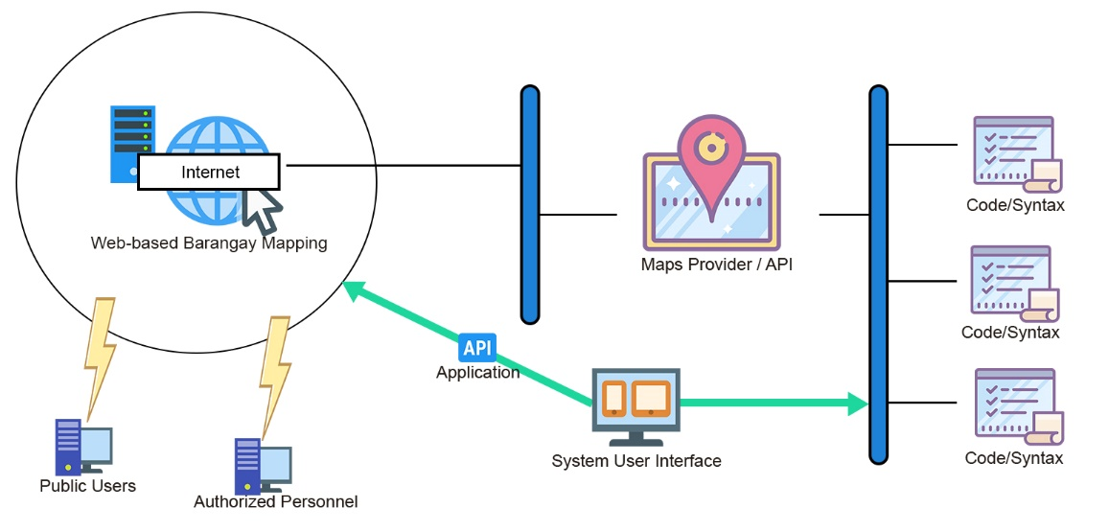

Figure 18. Infrastructure or Deployment.

**Bibliography**

[1] “Literature Review of GIS, PGIS and ICT”, 2020

[2] “Geographical *Information Systems (GIS)”*

[3] “*Orbit rolls out GIS mapping system for housing management”*

[4] “Barangay Decision Support and Mapping System”

[5] Allison Lynch,2021,“Program Flowchart Examples and Templates”, edrawsoft

[6] “System Flowcharts”, bbc.co

[7] Allison Lynch,2021,“What’s a Program Flowchart?| Definition and Example”, edrawsoft

[8] “What is Data Dictionary”,tutorialspoint

[9] “What is System Network Architecture”,ibm

[10] 2001, “Network Models”,informit

[11] “What is Network Topology”,omnisci

[12] “What is Security Architecture? ”,techslang

[13] 2020 ,“Tips to Write a Technical…”,wishdesk

[14] AndrewBurak,“How to Write Software Requirements…”,relevant.software

[15] “Program Specification”,oxfordreference

[16] “Deployment Diagram for a typical Web-based application”, researchgate

[17] “What is unit Testing?..”software quality.techtargt

[18] 2020,“Integration Testing”,u-tor

[19] Satyabrata_Jena,2021,“Compatibility Testing in Software Engineering”geeksforgeeks

[20] “What is Integration Testing (Tutorial with Integration Testing Example)”,google

[21] Thomas Hamilton,2021,”TEST PLAN:What is,How to Create(with Example)”,gu

[22] “Identity Management Infrastracture Deployment Planning”,docs.oracle

[23] Thembani Thembani,“Requirements+ Modeling”,studylib

[24] Alexander S. Gillis,“What is Performance Testing?”,hsoftwarequality.techtarget

[25] Austin Miller,2021,“Performance Testing, Load Testing & Stress Testing Explained”,bmc

[26] Thomas Hamilton,2021,“Performace Testing Tutorial:What is, Types,Metrics & Example”,guru99

[27] Thomas Hamilton,2021,“What is System Testing? Types & Definition with Example”,guru99

[28] “System Testing”,javapoint

[29] Adam Hayes,2020,“Acceptance Testing”,Investopedia

[30] “User Acceptance Testing…”,performancelabus

[31] 2019,“What is Acceptance Testing? Types and Example-W3Softech”,w3softech

[32] 2020,“Acceptance Testing in Software Engineering”,prepinsta

[33] Team Asana,2021,“What is an Implementation plan?6 steps to create one”,asana

[34] “Implemantation Checklist”,learn.nes.nhs.scot

[35] “Project Implemantation Checklist”,google

[36] Clive Longbottom, Stephen J. Bigelow,“What is Infrastructure…”,earchdatacenter.techtarget

[37] “Deployment Infrastructure”,ibm

**APPENDICES**

**APPENDIX A**

**Relevant Source Code**

Creating parameter for Pie Graph

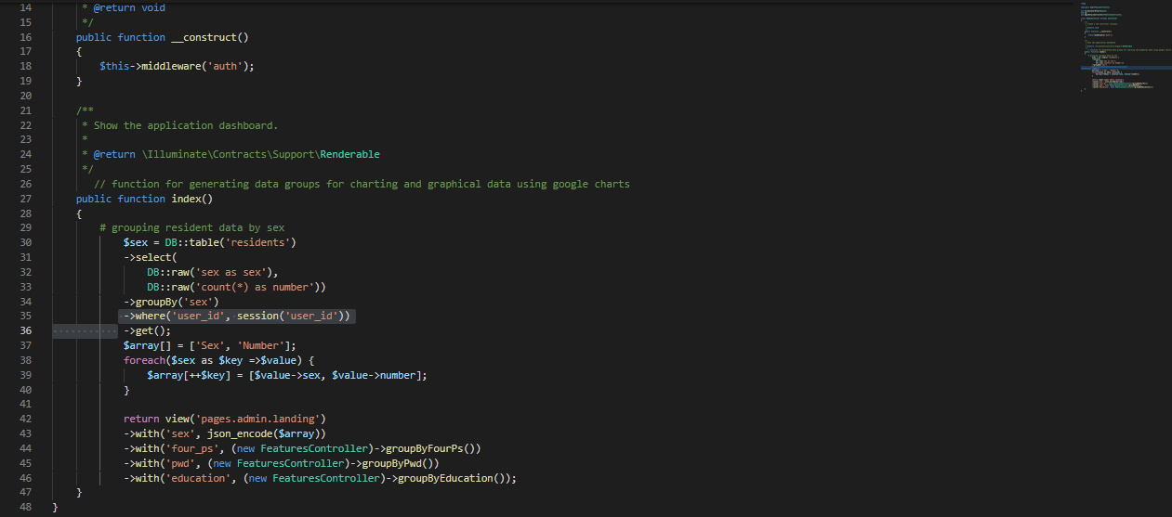

Request Routes

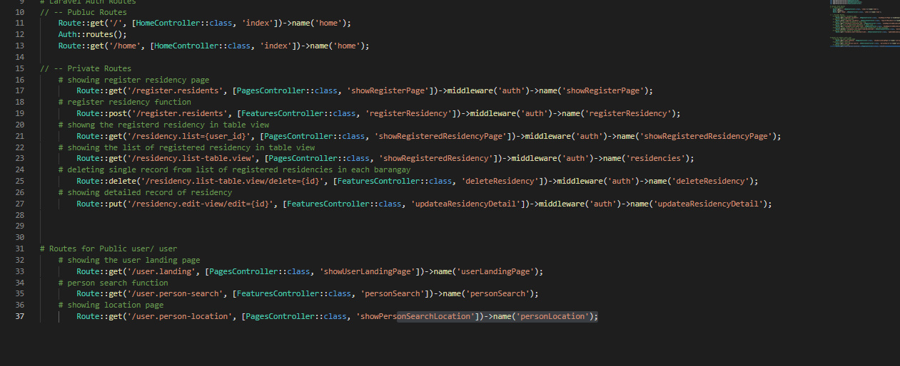

**APPENDIX B**

**Evaluation Tool**

**System Evaluation (ISO 9126)**

**Instructions:** Please evaluate the “Web-based Barangay Mapping in Brgy. Consolascion, Sogod, Southern Leyte” using the scale shown below. Check (/) the appropriate score. Thank you.

Dinalyn V. Dueñas Jorton Tagud

Programmer Adviser

**Qualitative Description per Functionality Indicator**

|  |  |
| --- | --- |
| **Limits of Scale** | **Qualitative Description** |
| 4.21 – 5.00 | Fully Functional |
| 3.21 – 4.20 | Mostly Functional |
| 2.61 – 3.20 | Functional |
| 1.81 – 2.60 | Slightly Functional |
| 1.0 – 1.8 | Not Functional |

**Qualitative Description per Usability Indicator**

|  |  |
| --- | --- |
| **Limits of Scale** | **Qualitative Description** |
| 4.21 – 5.00 | Fully Usable |
| 3.21 – 4.20 | Mostly Usable |
| 2.61 – 3.20 | Usable |
| 1.81 – 2.60 | Slightly Usable |
| 1.0 – 1.8 | Not Usable |

|  |  |  |  |  |  |  |
| --- | --- | --- | --- | --- | --- | --- |
| **Criteria** | | **Score** | | | | |
| *Characteristics* | *Sub Characteristics* | **1** | **2** | **3** | **4** | **5** |
| Functionality | The application performs the required functionalities |  |  |  |  |  |
| The application provides the expected result |  |  |  |  |  |
| Usability | The graphical user interface of the application is easy to use or navigate |  |  |  |  |  |
| The displayed results of the system are understandable |  |  |  |  |  |

**APPENDIX C**

**Sample Input and Output**

Sample Input

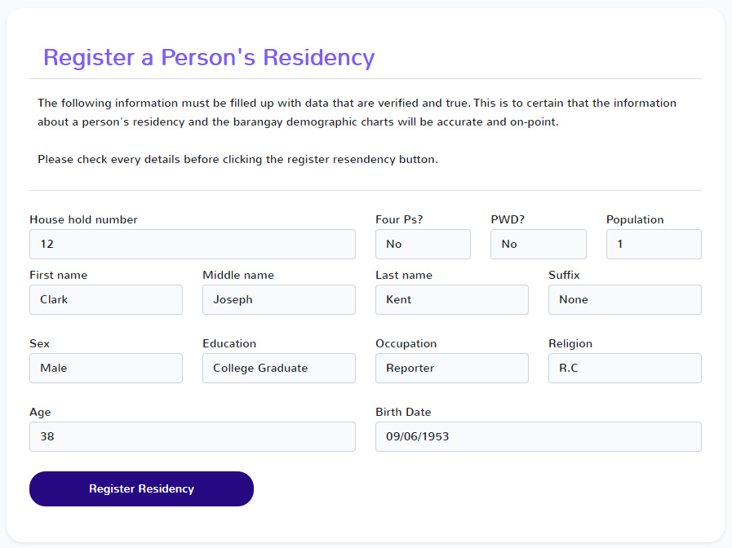

Sample Output

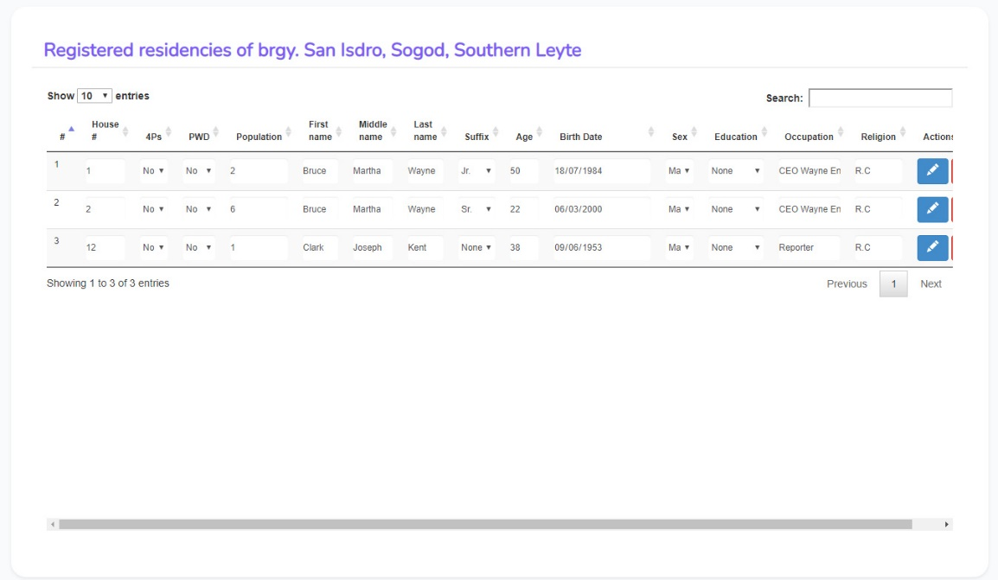

**APPENDIX D**

**User’s Guide**

Login form

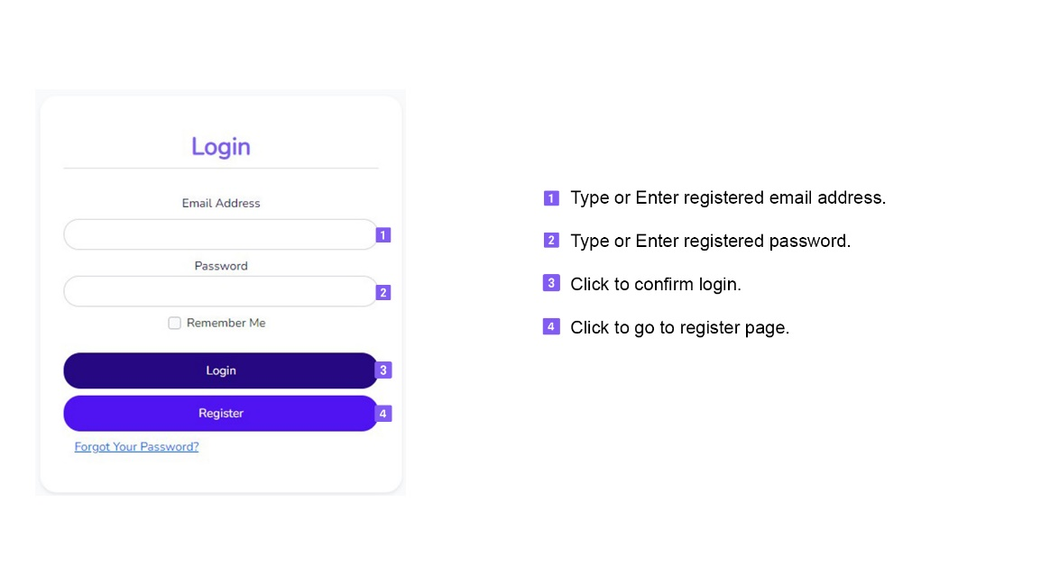

Register form

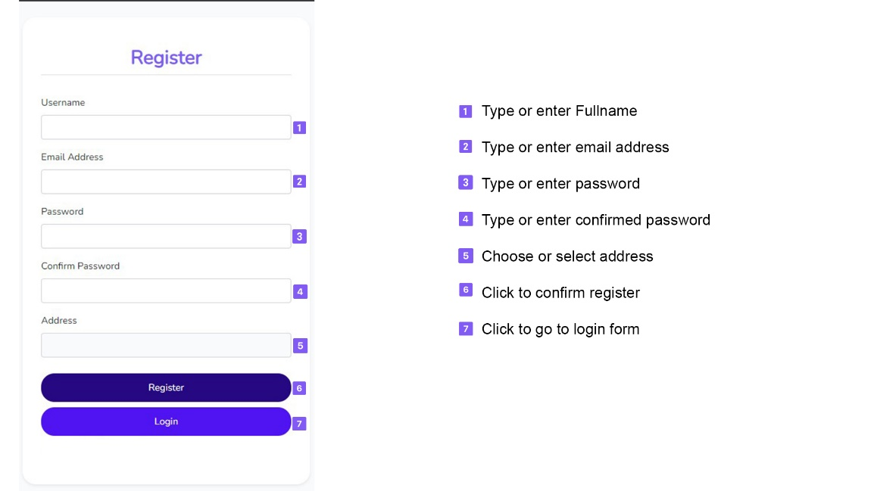

Register a Person’s Residency

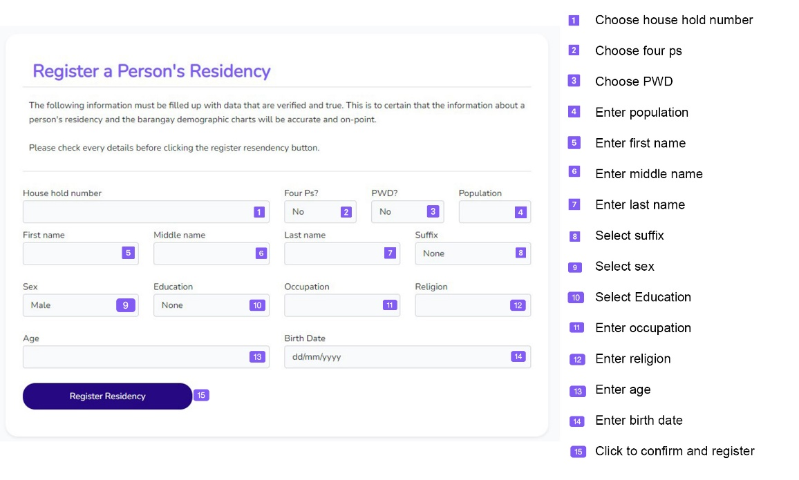

Person search

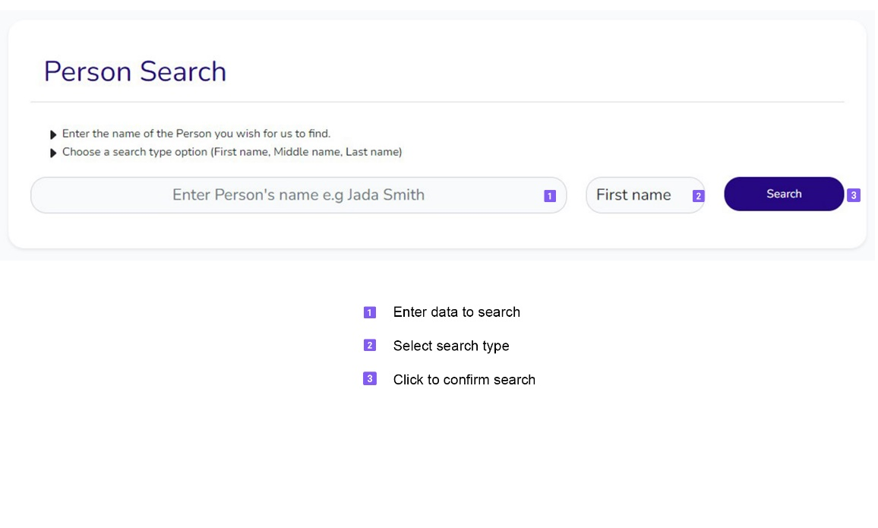

**APPENDIX E**

**Other Relevant Documents**

Env file

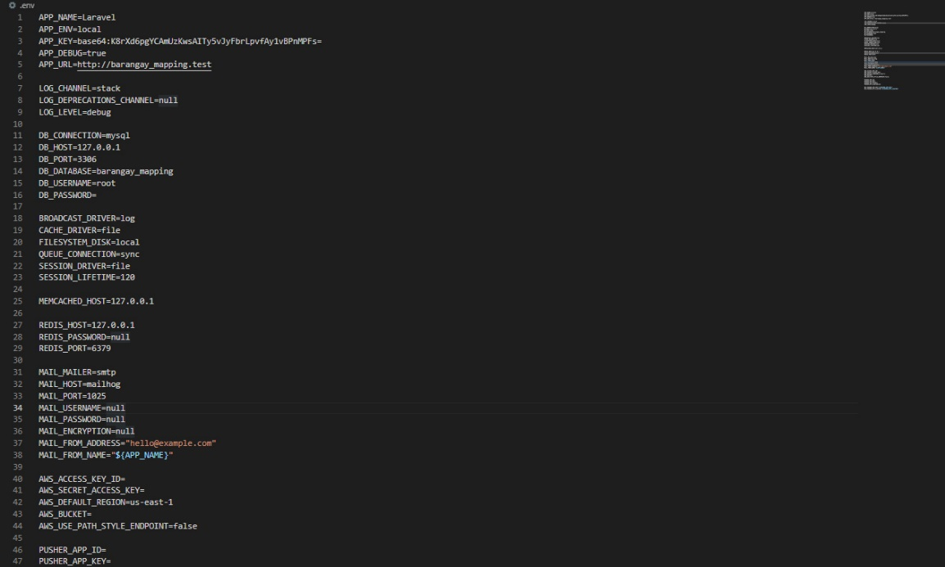

Layouts.blade.php file

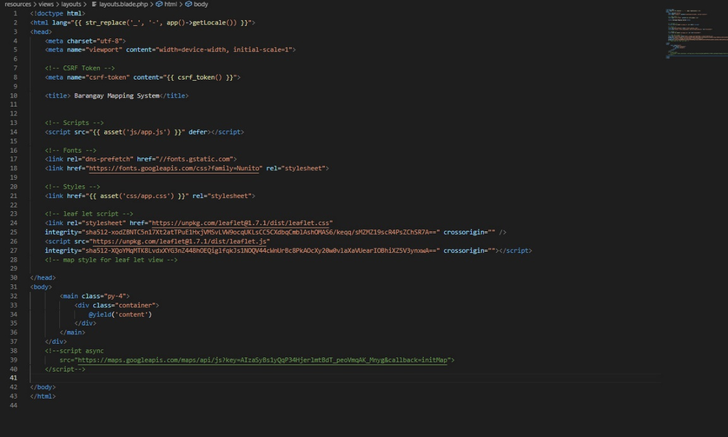

**APPENDIX F**

**Working Title Form**

Republic of the Philippines

**SOUTHERN LEYTE STATE UNIVERSITY**

Sogod, Southern Leyte

Website: [www.slsuonline.edu.ph](http://www.slsuonline.edu.ph)

Email: [slsumaincampus@gmail.com](mailto:slsumaincampus@gmail.com)

op@slsuonline.edu.ph Telefax No. (053) 382-3294

***College of Computer Studies and Information Technology***

**Proponents/Researchers:**

|  |
| --- |
| Marie Glaiza C. Cinco |
| Ma. Rotchelle C. Rosales |
| Dinalyn V. Dueñas |
| Allysa S. Calope |
| Jemuel J. Geodias |

**Proposed Project Title:**

|  |
| --- |
| **Web-based Barangay Mapping in Brgy. Consolascion, Sogod, Southern Leyte** |

|  |  |
| --- | --- |
| **Submitted by:**  **Marie Glaiza C. Cinco**  (Signature of Project Manager over printed name)  Date: | **Noted:**  **Jorton Agda Tagud, SGD**  (Signature of Adviser over printed name)  Date: |
| **Recommending Approval:**  (Signature of Patent Searcher over printed name)  Date: | **Approved:**  **Alex C. Bacalla, DIT**  (Signature of Dean over printed name)  Date: |

**APPENDIX G**

**Grammarians’ Certification**

Republic of the Philippines

**SOUTHERN LEYTE STATE UNIVERSITY**

Sogod, Southern Leyte

Website: [www.slsuonline.edu.ph](http://www.slsuonline.edu.ph)

Email: [slsumaincampus@gmail.com](mailto:slsumaincampus@gmail.com), [op@slsuonline.edu.ph](mailto:op@slsuonline.edu.ph)

Telefax No. (053) 382-3294

***College of Computer Studies and Information Technology***

Date: _____________

**G R A M M A R I A N ‘ S C E R T I F I C A T E**

This is to certify that the undersigned has reviewed and went through all the pages of the proposal project study / research entitled “Web-based Barangay Mapping in Brgy. Consolascion, Sogod, Southern Leyte” as against the set of structural rules that governs the composition of sentences, phrases, and words in the English language.

Signed:

_________________________

Grammarian

Conformed:

**Marie Glaiza C. Cinco**

Project Manager

**APPENDIX H**

**Curriculum Vitae**

**MARIE GLAIZA C. CINCO**

Brgy. Consolacion, Sogod, Southern Leyte

+63938 – 005 – 8484

marieglaiza99@gmail.com

**PERSONAL INFORMATION**

Nickname : Glaiza

Date of Birth : December 11, 1999

Place of Birth : Sogod District Hospital

Civil Status : Single

Citizenship : Filipino

Age : 22

Gender : Female

Religion : Roman Catholic

Father's Name : Romeo Kenn S. Cinco

Mother's Name : Shirley C. Cinco

**EDUCATIONAL ATTAINMENT**

Tertiary Education : Southern Leyte State University

Year : 2021-Present

Course : Bachelor of Science in Information Technology

Major : Networking

Address : Brgy. San. Roque, Sogod, Southern Leyte

Secondary Education : Sogod National High School

Year : 2017 - 2018

Strand : GAS

Specialization : Academic Strand

Address : Zone 1, Sogod, Southern Leyte

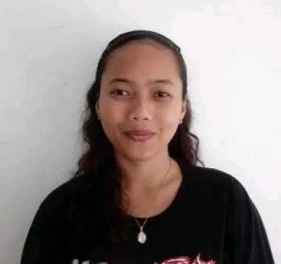 **MA. ROTCHELLE C. ROSALES**

Brgy. Lamak, Hilongos, Leyte

+63938 – 769 – 9407

rotchellemaria@gmail.com

**PERSONAL INFORMATION**

Nickname : Rotchelle

Date of Birth :

Place of Birth : Hilongos, Leyte

Civil Status : Single

Citizenship : Filipino

Age : 21

Gender : Female

Religion : Roman Catholic

Father's Name : Antonio Rosales

Mother's Name : Gilda Rosales

**EDUCATIONAL ATTAINMENT**

Tertiary Education : Southern Leyte State University

Year : 2021-Present

Course : Bachelor of Science in Information Technology

Major : Networking

Address : Brgy. San. Roque, Sogod, Southern Leyte

Secondary Education : Hilongos National Vocational School

Year : 2017 - 2018

Strand : TVL

Specialization : Dressmaking

Address : RV. Fulache St.

**DINALYN V. DUEÑAS**

Brgy. Lamak, Hilongos, Leyte

+63906 – 822 – 4468

ddinalyn22@gmail.com

**PERSONAL INFORMATION**

Nickname : Dina

Date of Birth :

Place of Birth : Balinsasayaw, Abuyog, Leyte

Civil Status : Single

Citizenship : Filipino

Age : 26

Gender : Female

Religion : Roman Catholic

Father's Name : Delfin M. Dueñas

Mother's Name : Gina V. Dueñas

**EDUCATIONAL ATTAINMENT**

Tertiary Education : Southern Leyte State University

Year : 2021-Present

Course : Bachelor of Science in Information Technology

Major : Networking

Address : Brgy. San. Roque, Sogod, Southern Leyte

Secondary Education : Hilongos National Vocational School

Year : 2011 - 2012

Address : RV. Fulache St.

 **ALLYSA S. CALOPE**

Brgy. Rizal, Sogod, Southern Leyte

+63975 – 386 – 8805

allysacalope@gmail.com

**PERSONAL INFORMATION**

Nickname : Lysa

Date of Birth : July 03, 2000

Place of Birth : Rizal, Sogod, Southern Leyte

Civil Status : Single

Citizenship : Filipino

Age : 21

Gender : Female

Religion : Born Again

Father's Name : Jaime T. Calope

Mother's Name : Virginia S. Singson

**EDUCATIONAL ATTAINMENT**

Tertiary Education : Southern Leyte State University

Year : 2021-Present

Course : Bachelor of Science in Information Technology

Major : Networking

Address : Brgy. San. Roque, Sogod, Southern Leyte

Secondary Education : Sogod National High School

Year : 2017 - 2018

Strand : TVL

Specialization : Bread and Pastry

Address : Zone 1, Sogod, Southern Leyte

 **JEMUEL J. GERODIAS**

Brgy. Higusoan, Tomas Oppus, Southern Leyte

+63965 – 380– 3942

jemssygerodias@gmail.com

**PERSONAL INFORMATION**

Nickname : Jem/Jemssy

Date of Birth : July 27, 1996

Place of Birth : Quezon City, NCR

Civil Status : Single

Citizenship : Filipino

Age : 25

Gender : Male

Religion : Roman Catholic

Father's Name : Gaspar Gerodias

Mother's Name : Gina Gerodias

**EDUCATIONAL ATTAINMENT**

Tertiary Education : Southern Leyte State University

Year : 2021-Present

Course : Bachelor of Science in Information Technology

Major : Networking

Address : Brgy. San. Roque, Sogod, Southern Leyte

Secondary Education : Sogod National High School

Year : 2017 - 2018

Strand : TVL

Specialization : Bread and Pastry

Address : Zone 1, Sogod, Southern Leyte